Name | S KUSHAL SIMHA RAO
Class | 8 T

Purpose:
"Skill Assessment Program - Building Strengths Beyond Academics "
This report shows your child's interests and abilities in different school activities. With your (parents) support and our guidance, these strengths can grow into useful life skills. It helps parents notice early signs of talent and areas where extra care or practice can make a big difference.

Key Insights:
The graph below shows how your child is doing in different areas. It tells us what they like more and where we can help them do even better. Blue represents your child, and orange represents the class average.
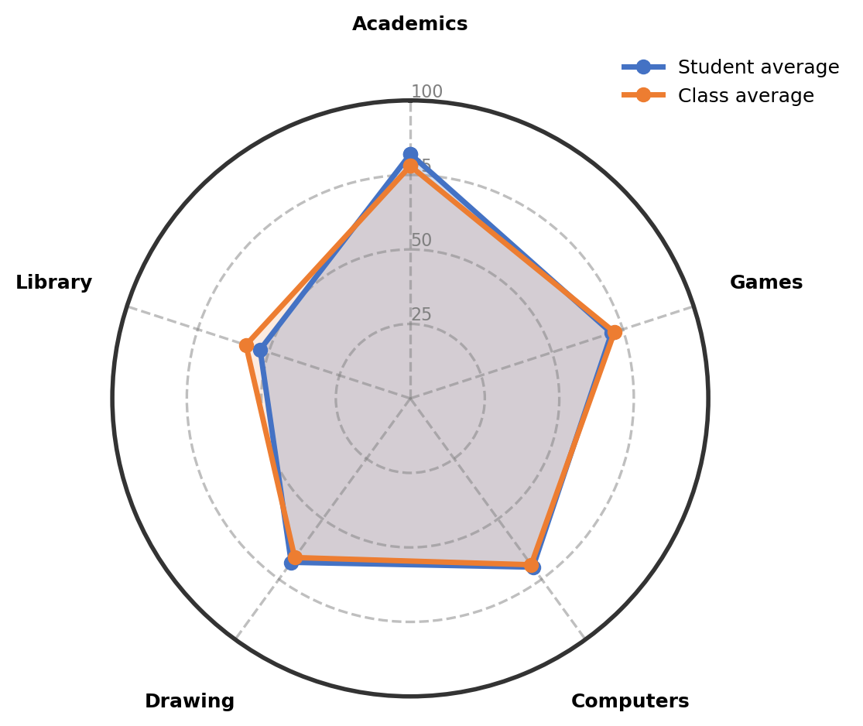

Observations:
The table gives an overview of child's involvement and performance across co-curricular areas.
Interest Area | Engagement (%) | Interest Level | Key Observations
Academics | 82% | Well-Developed Interest | The child shows strong curiosity in Physics, especially topics like force and friction.
Games | 71% | Showing Strong Interest | Enjoys playing Kho Kho and shuttle, and also shows interest in cricket.
Computers | 70% | Positive and Active Engagement | Answers and performs well, especially interested in animation.
Drawing | 68% | Showing Strong Interest | Gauges shading and core shadows accurately; interested in anime drawings.
Library | 53% | Emerging Interest | Prefers comic books and folk tales; reading focus is good but grammar needs improvement.

Recommendations & Growth Opportunities:
Here are some ways to turn your child's interests into long-term strengths:
Strong Interest Area | Potential Careers | Simple Activities to Support
Academics  (82%) | Strong academic performance, especially in Physics, opens many exciting fields. Exploring Robotics/Mechatronics Engineer, AI/ML Engineer, Biotechnologist, or Clinical Psychologist is very possible. Building a solid foundation in Science now will keep many doors open. | 1. Enroll in a JEE/NEET foundation course or Science Olympiad coaching to deepen Physics understanding and problem-solving skills  2. Encourage participation in science fairs or workshops on robotics and mechanics to apply force and friction concepts  3. Provide age-appropriate physics experiment kits or books to explore topics beyond school curriculum.
Games  (71%) | Active participation in Kho Kho, shuttle, and cricket can lead to exciting careers. Exploring Fitness Trainer/Instructor, Sports Manager/Agent, Sports Data Analyst, or Armed Forces Officer could be great directions. These fields reward athletic skill, teamwork, and strategic thinking. | 1. Enroll in a structured cricket or badminton academy to refine skills through regular coaching  2. Encourage participation in school or inter-school sports competitions to build competitive spirit and confidence  3. Provide opportunities to learn about sports nutrition or watch professional matches to understand game tactics.

How Parents Can Help:
1. 1. Weekend Exploration (Academics - Physics): Dedicate a weekend afternoon to a fun physics experiment using simple materials (like making a balloon car or paper bridge) to explore force and friction concepts hands-on.
2. 2. Short Daily Practice (Games): Encourage 15 minutes of shuttle practice or basic cricket drills in the evening to maintain physical fitness and improve coordination.
3. 3. Encourage and Talk: Dedicate 10–15 minutes weekly to ask about favorite sports moments or science experiments, listen actively, and appreciate the effort shown in both areas.

Conclusion:
The child has strong academic curiosity in Physics and a natural enthusiasm for sports. Both interests are developing well and offer many exciting opportunities for the future. Encouraging steady practice and exploration in both areas will help build confidence and important skills. Keep supporting these interests with simple, fun activities at home.

Notes:
Parents remarks:
Teachers' remarks:

